**PROGRAM 1: INSURANCE DATABASE**

Consider the Insurance database given below. The primary keys are underlined and the data types are specified.

PERSON (driver-id #: String, name: String, address: String)

CAR (Regno: String, model: String, year: int)

ACCIDENT (report-number: int, date: date, location: String)

OWNS (driver-id #: String, Regno: String)

PARTICIPATED (driver-id: String, Regno: String, report-number: int, damage-amount: int

**i. Create the above tables by properly specifying the primary keys and the foreign keys**

create database Supriya;

use Supriya;

create table person(

driver_id varchar(10),

name varchar(20),

address varchar(20),

primary key(driver_id));

desc person;

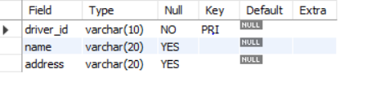

create table car

(

Reg_no varchar(10),

model varchar(10),

year int(10),

primary key(Reg_no));

desc car;

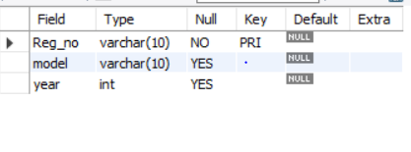

create table accident(

Report_no int(10),

accident_date date,

location varchar(20),

primary key(Report_no));

desc accident;

create table owns

(

driver_id varchar(10),

Reg_no varchar(10),

primary key(driver_id,Reg_no),

foreign key(driver_id)references person(driver_id),

foreign key(Reg_no)references car(Reg_no));

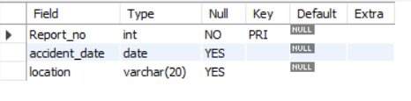

create table participated

(

driver_id varchar(10),

Reg_no varchar(10),

report_num int,

damage_amount int,

primary key(driver_id,Reg_no,report_num),

foreign key(driver_id)references person(driver_id),

foreign key(Reg_no)references car(Reg_no),

foreign key(report_num)references accident(Report_no));

desc participated;

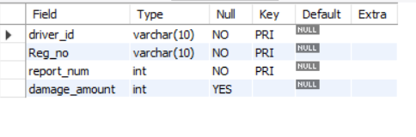

**ii. Enter at least five tuples for each relation**

use Supriya;

insert into person values(1,'Ravi','Dharwad');

insert into person values(2,'Raj','Hubli');

insert into person values(3,'sujal','Banglore');

insert into person values(4,'Ram','Davangere');

insert into person values(5,'Rishi','Mysore');

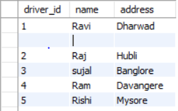

insert into car values(1,'Benz','2001');

insert into car values(2,'suzuki','2002');

insert into car values(3,'BMW','2003');

insert into car values(4,'Wagon','2004');

insert into car values(5,'Sedan','2005');

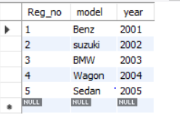

insert into accident values(1,'Ravi','Dharwad');

insert into accident values(2,'Raj','Hubli');

insert into accident values(3,'sujal','Banglore');

insert into accident values(4,'Ram','Davangere');

insert into accident values(5,'Rishi','Mysore');

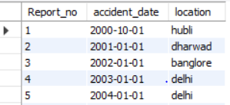

insert into owns values(1,1);

insert into owns values(2,2);

insert into owns values(3,3);

insert into owns values(4,4);

insert into owns values(5,5);

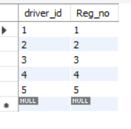

insert into participated values(1,1,1,200);

insert into participated values(2,2,2,100);

insert into participated values(3,3,3,300);

insert into participated values(4,4,4,400);

insert into participated values(5,5,5,500);

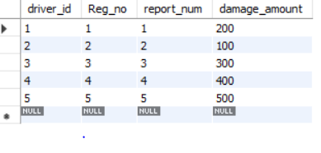

**iii) a.Update the damage amount for the car with a specific Reg_no in the accident with report number 5 to 25000.**

use Supriya;

update participated set damage_amount=25000 where Reg_no=5 AND report_num=5;

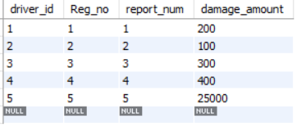

**b. Add a new accident to the database.**

use Supriya;

select * from accident;

insert into accident values(6,'2005-02-20','mumbai');

select * from accident;

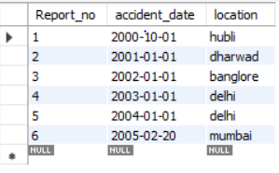

**iv) Find the total number of people who owned cars that involved in accidents in 2008.**

use Supriya;

select count(distinct driver_id)from participated p,accident a where p.report_num and a.accident_date like '2000-10-01';

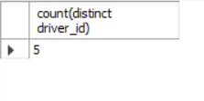

**v) Find the number of accidents in which cars belonging to a specific model were involved**

use Supriya;

select count(report_num)from car c,participated p where c.Reg_no=p.Reg_no and model='Benz';

